Enjoy 3e Flatmates

EPISODE 77: the advert

Listen and complete
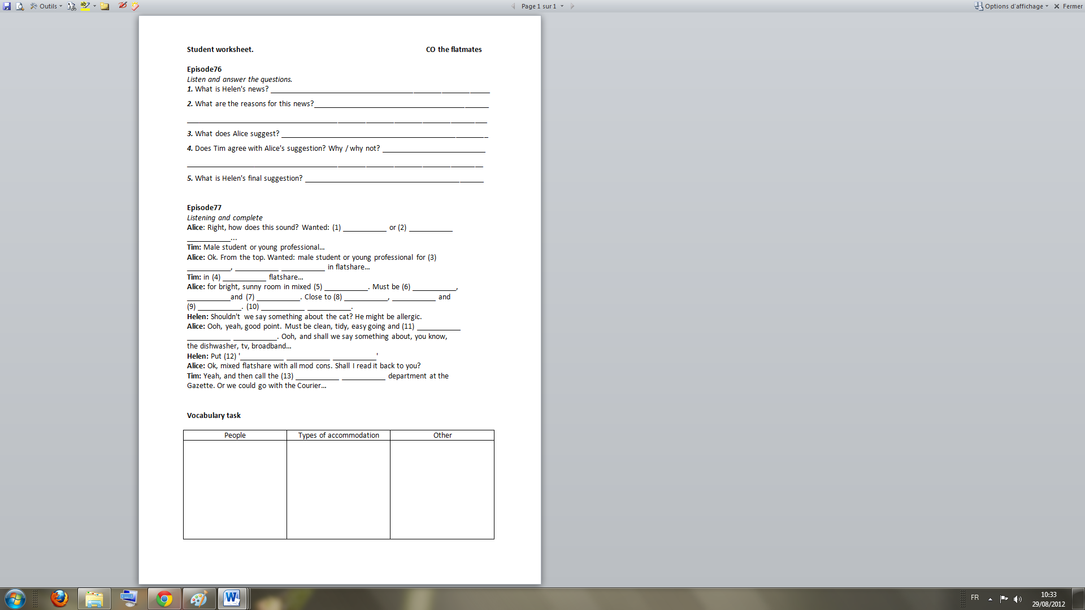

New words or expressions : bright – a flatshare – a flatmate – all mod cons / all modern conveniences – broadband – reasonable / unreasonable – a rent / to rent – a small ad / advert / advertisement – the classified ads – how does it sound?

