ENGLISH

1/Match the pictures to the English words
2/ Say if you must or mustn’t do these things in class

classroom rules


you mustn't
you must


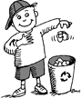
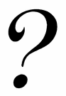
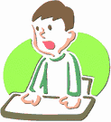
1. Be late
2. Do your homework regularly

3. Ask for permission to go
to the litter bin
A
T
4. Be in class on time
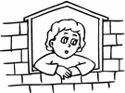
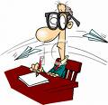
S
5. Eat in class
6. Help your friends
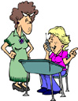
B
7. Listen to your teacher
8. Watch out of the window

R
during the lesson
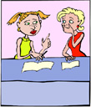
9. Do stupid things
Q
10. Bring your books, workbooks
C
and notebooks to every lesson.
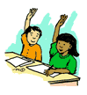
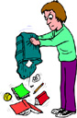
11. Use your cell phones in class
P
12. Sleep in class
13. Stand up without permission
14. Forget your book
D
15. Put up your hands
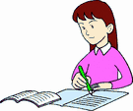
O
K
16. Chew gums
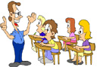
green
17. Use a green pen to correct
N
Your exercises
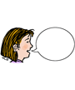
E
18. Be polite
M
19. Speak French during the
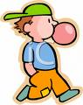
Oui !
pair work activities
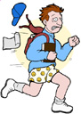
L
20. Chat in class
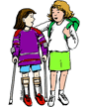
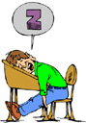
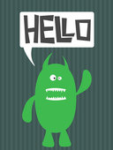
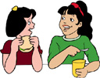
F
K
J
I
H
G

